**923141230**

Base URL:

* [**https://www.impan.pl/en/publishing-house/journals-and-series/applicationes-mathematicae/all**](https://www.impan.pl/en/publishing-house/journals-and-series/applicationes-mathematicae/all)

Select the issue from the issue list.

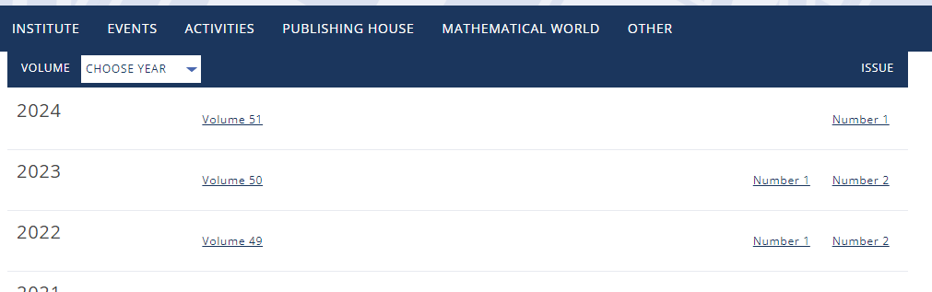

**Select the Current issue from here.**

All required articles will be listed here.

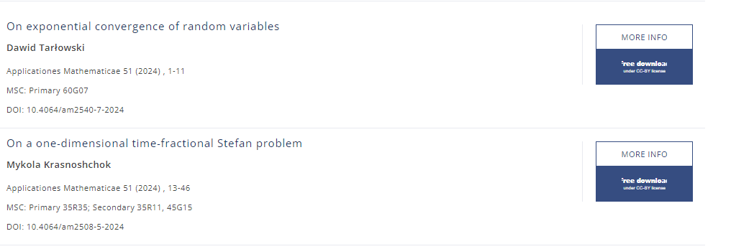

**Click here to download the pdf**

Meta data can be captured as below.

**Volume 51 issue 1 and Year**

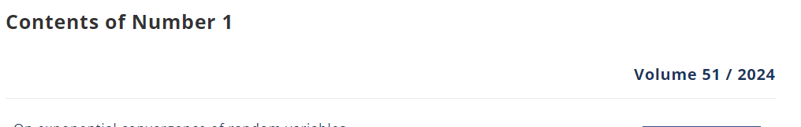

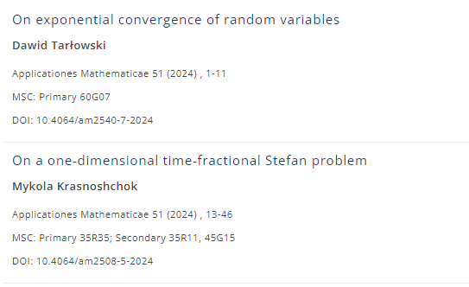

**Article Name**

**Page Range**

**DOI**